DAT602 – Milestone 1
Dylan Brodie
Table of Contents
Design 2
Logical ERD 6
CRUD Operations 7
DDL Implementation & Testing 7
Prototype 7

Design
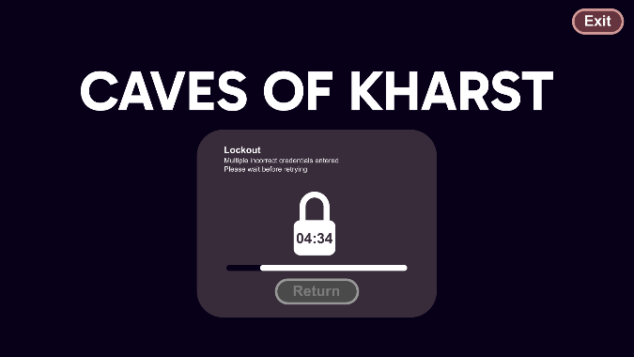
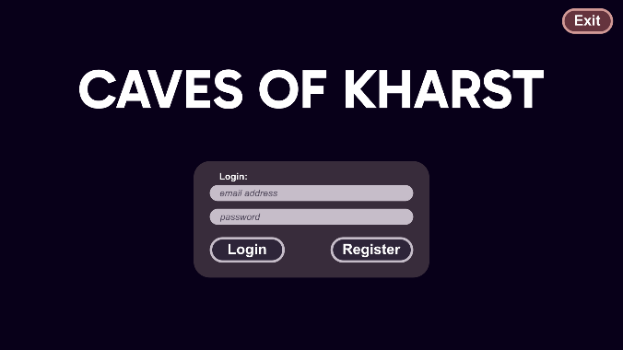
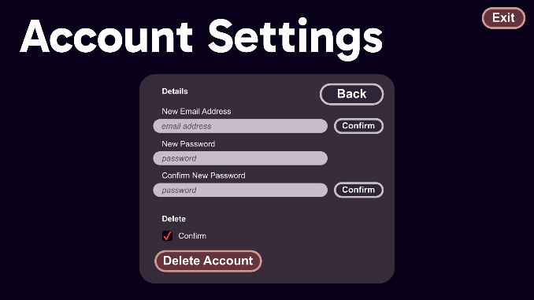
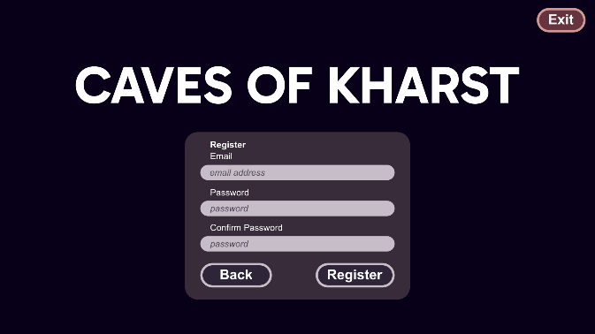
“Caves of Kharst” is a multiplayer, extraction, dungeon delving, puzzle adventure where teams of up to four wizards enter a randomly generated cave, tasked with retrieving the magical gems contained within before the time limit is reached. Player log into a central database using an email and password. Players then choose or create a character to play as
10.
9.
8.
7.
6.
3.
2.
5.
4.
1.

1. | Exit Button | 6. | Registration input fields
2. | Login Inputs | 7. | Back Button
3. | Login Button | 8. | Register Button
4. | Register Button | 9. | Confirmation check
5. | Lockout Timer | 10. | Delete Account Button

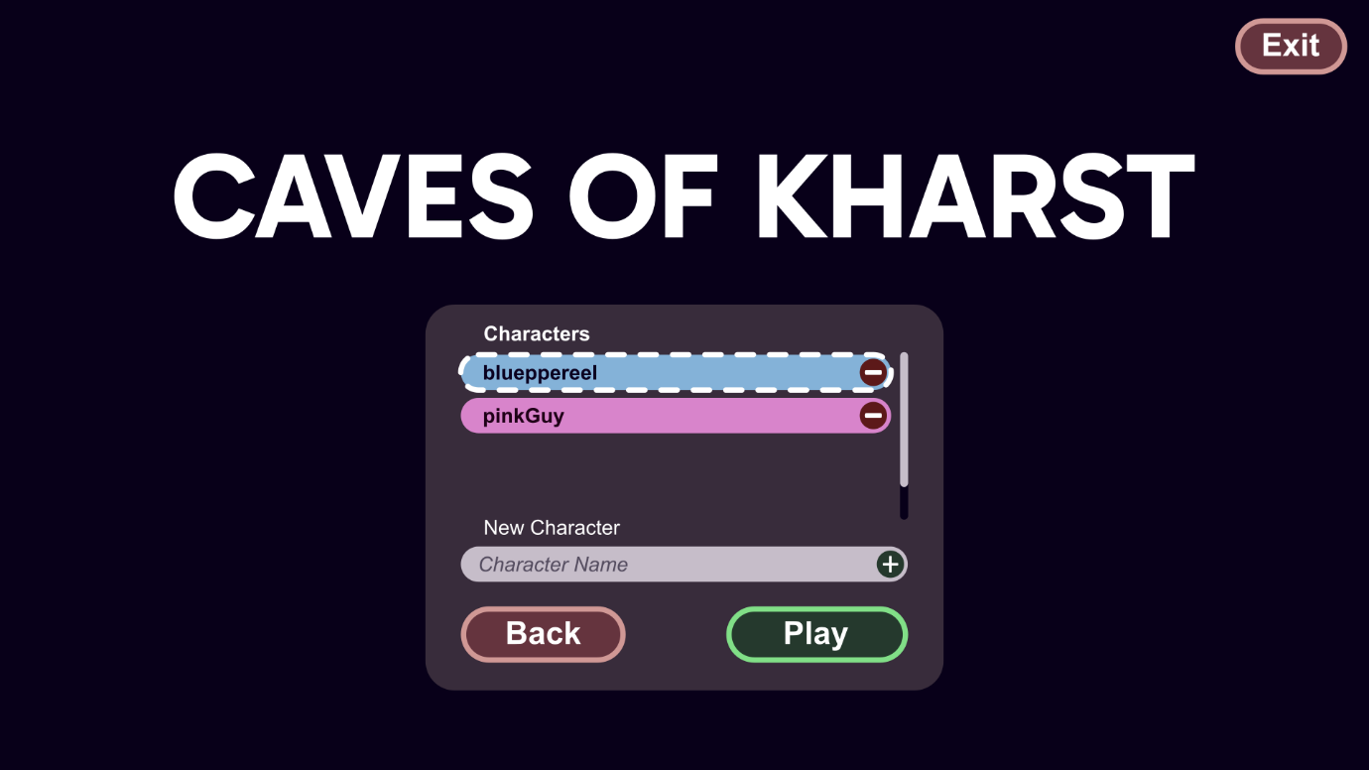
4.
3.
2.
1.
1. | Character Selection | 3. | Exit Button
2. | Character Creation | 4. | Play Button
Players start in a lobby where they form teams of up to four players before entering the caves. Before they enter, they may trade their previously collected gems for upgrades at a shop. There is also a wardrobe where they may customise their character colour. Players may take any gem from their collection to hold in their inventory and take their inventory items into the caves with them, allowing for customisable loadouts.
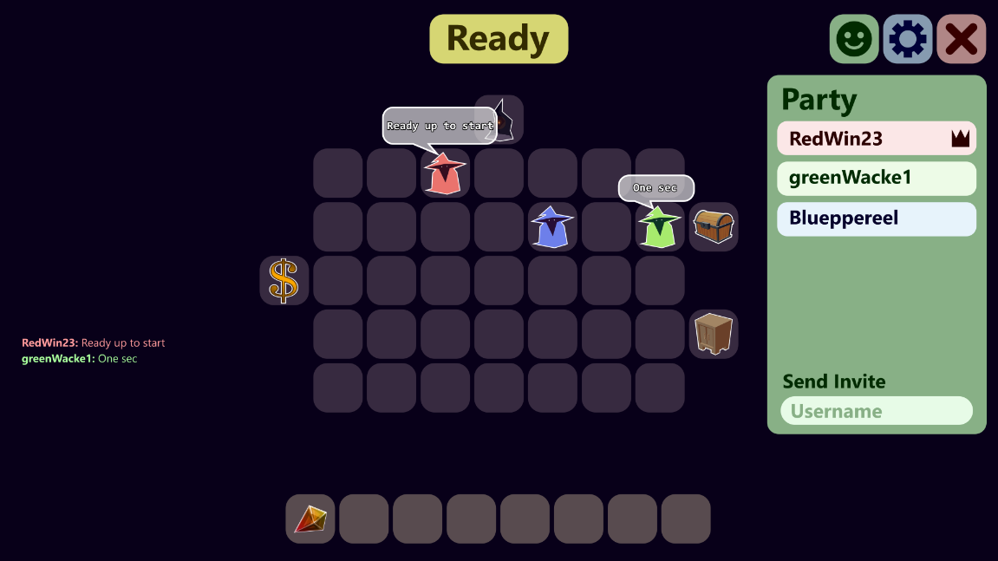
7.
7.
6.
5.
4.
2.
1.
2.
1. | Player Character | 5. | Menu buttons
2. | Inventory | 6. | Party Menu
3. | Interactable Entity | 7. | Party Invitation
4. | Chat | 8. | Ready Button

The caves are made of many separate caverns, which are navigated via doorways between caverns. An entire cave may contain as many as 50 individual caverns. While cave layouts are randomly generated, stitching many caverns together, the individual caverns have set layouts with randomly selected items. i.e. enemies are randomly selected from a pool and placed at the defined locations in the cavern template.
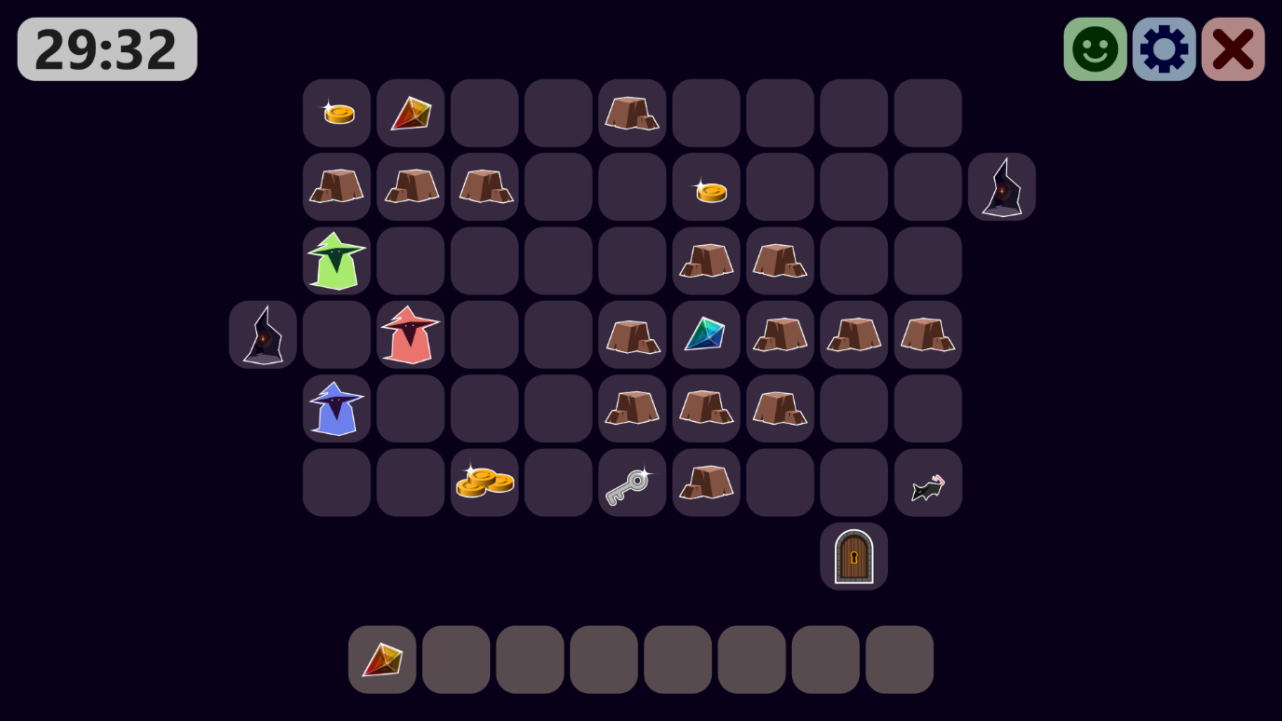
7.
4.
5.
8.
3.
2.
6.
1.
1. | doorway connecting rooms | 5. | Game Timer
2. | Impassable rocks | 6. | Locked doorway
3. | Gold | 7. | Magical Gem
4. | Key | 8. | Enemy Rat
While each players collection can hold an unlimited amount, inventories are limited to eight slots. While all items take up a single slot, some may stack, such as coins, which may be used at various places in the caves such as merchants, vending machines, etc. or keys which are used to open locked doors and chests.
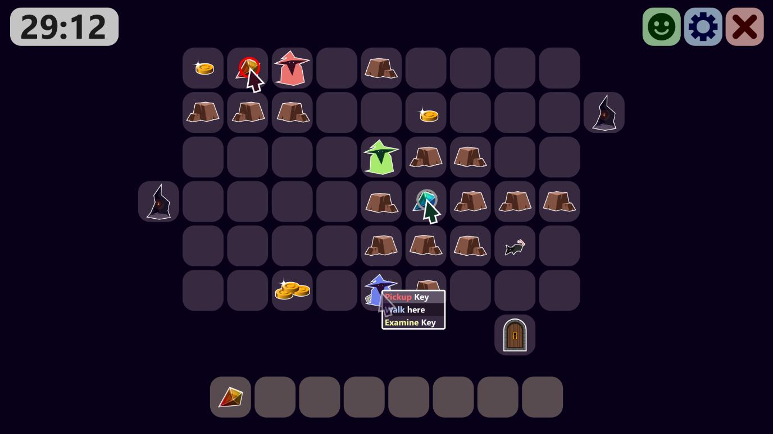
4.
3.
2.
1.
1. | Valid object interaction | 3. | Right click menu
2. | invalid interaction (no path) | 4. | Enemy movement
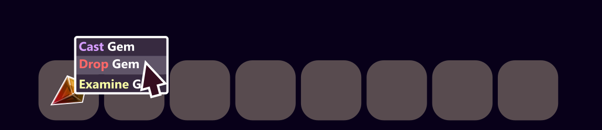
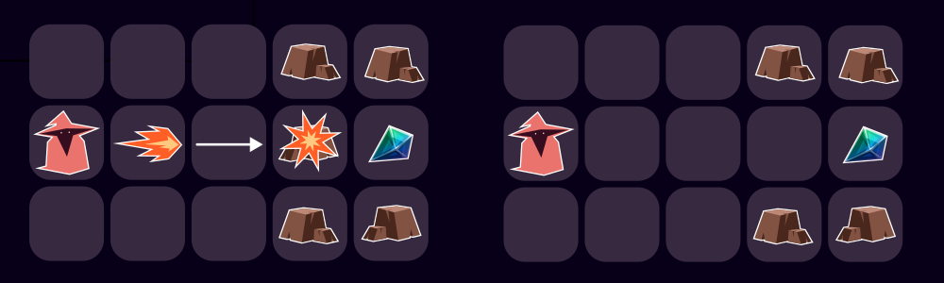
The gems contain magical power and can be consumed to cast magical spells. These spells can manipulate the environment and characters in various ways, such as teleportation, destroying entities, reviving players etc. As players are only scored based on what they bring out of the caves, they are incentivised to use the magical spells only when needed, and to prioritise gems of high value. E.g. an explosion gem valued at 500 points is worth using to access a gem worth 1000, but not one worth 100, unless it could be useful for further delving.
3.
4.
2.
1.
1. | Cast option | 3. | Destroyed rock
2. | Gem effect | 4. | Accessible gem

If players escape the caves before the time limit is up, all items retrieved thus far will be tallied up for a total score for the game. Players are able to stash unlimited amounts of items in the chest and use the shop to purchase items using gems or coins. Once the time limit is up, all players still within will be lost along with their held items.
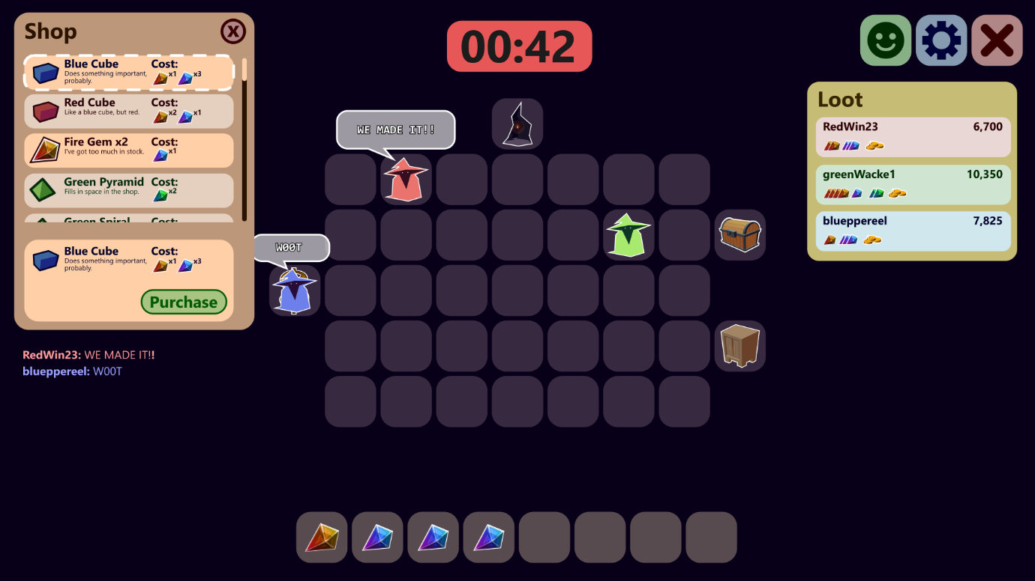
4.
3.
2.
1.
5.
1. | Shop interface | 4. | Purchase button
2. | Selected shop item | 5. | Game leaderboard
3. | Selected shop item details
Administrators are able to access a special menu if their account if flagged as an administrator. For safety purposes, administer accounts cannot be edited via the in game menu and must be created and managed within the database. Administrators may view and close games in progress as well as search and edit player information, including deleting player accounts.

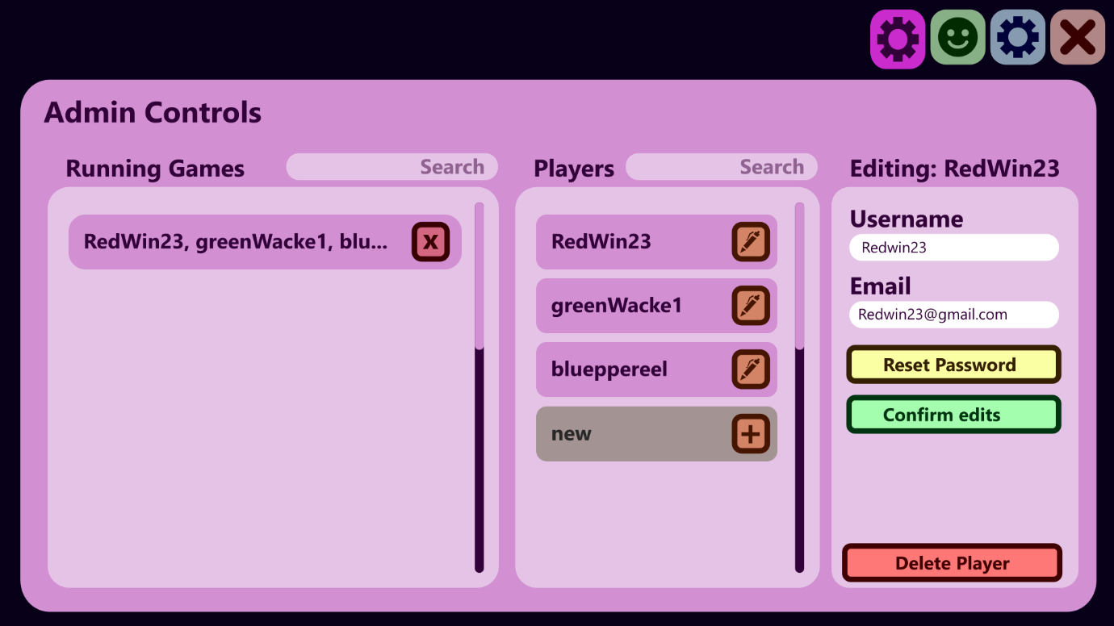
4.
6.
5.
4.
4.
3.
2.
1.
1. | All running games | 4. | Edit details button
2. | Search tool | 5. | New player button
3. | End Game button | 6. | Player Detail editing interface
4. | List of all players | 7. | Delete Player button

Logical ERD
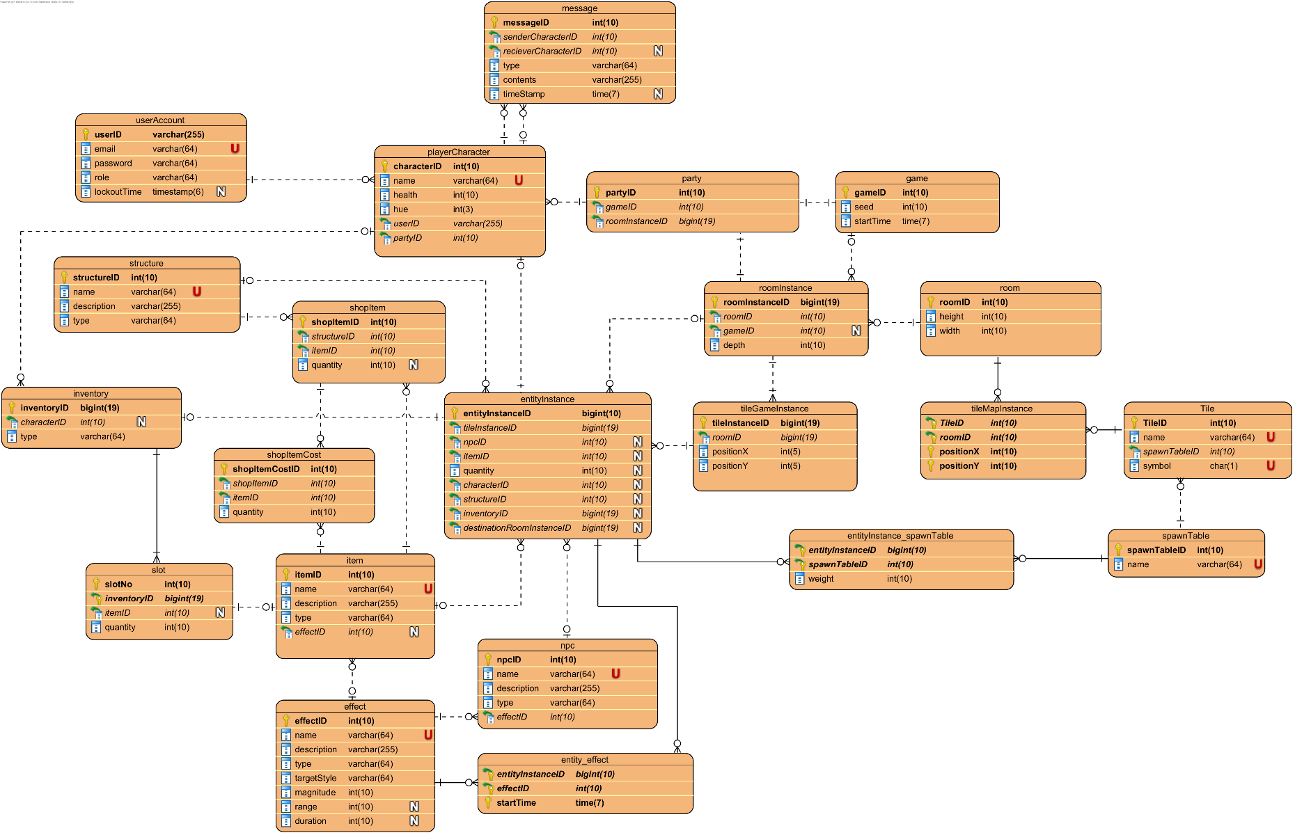

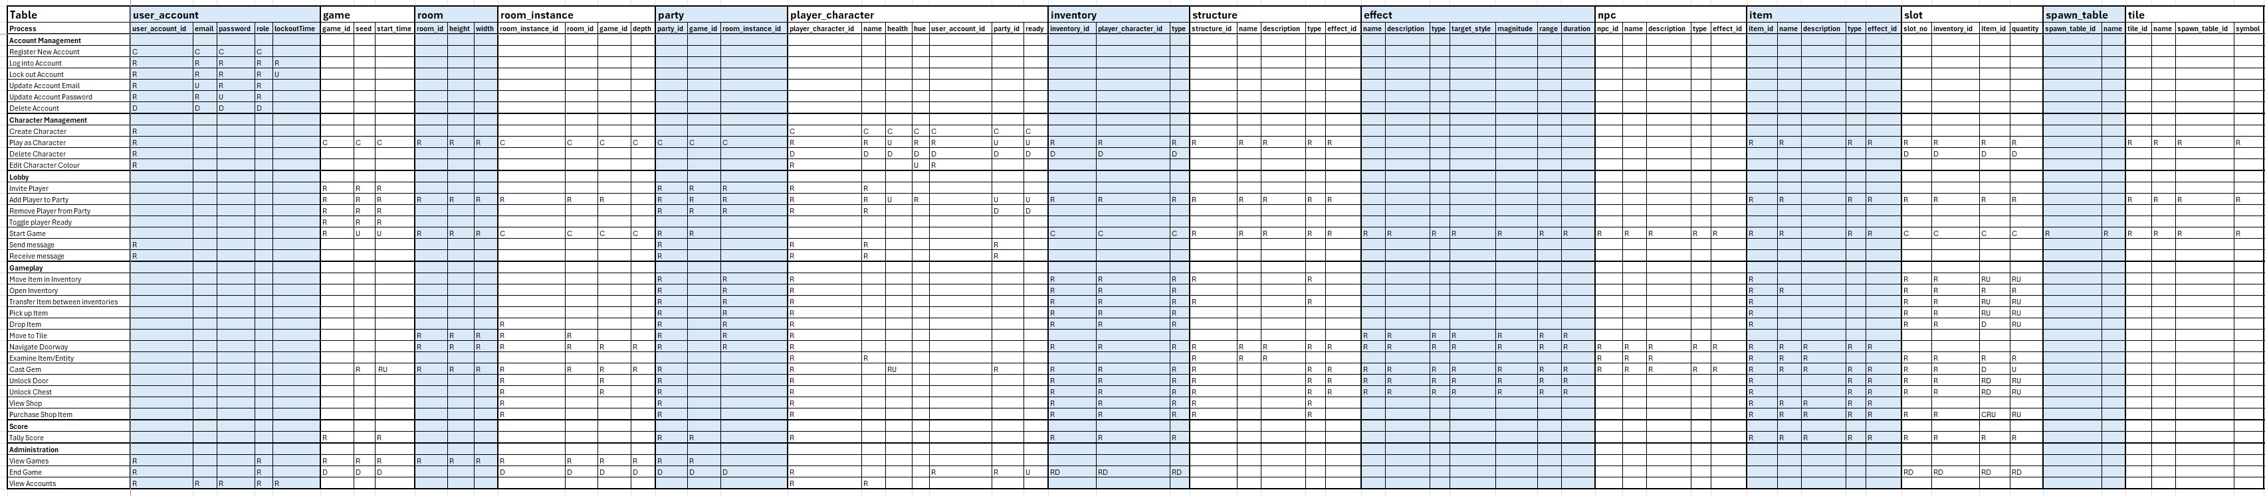
CRUD Operations
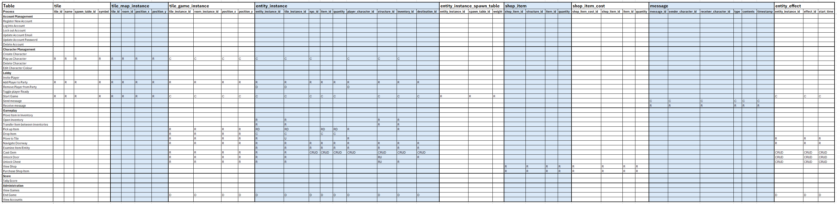

DDL Implementation & Testing
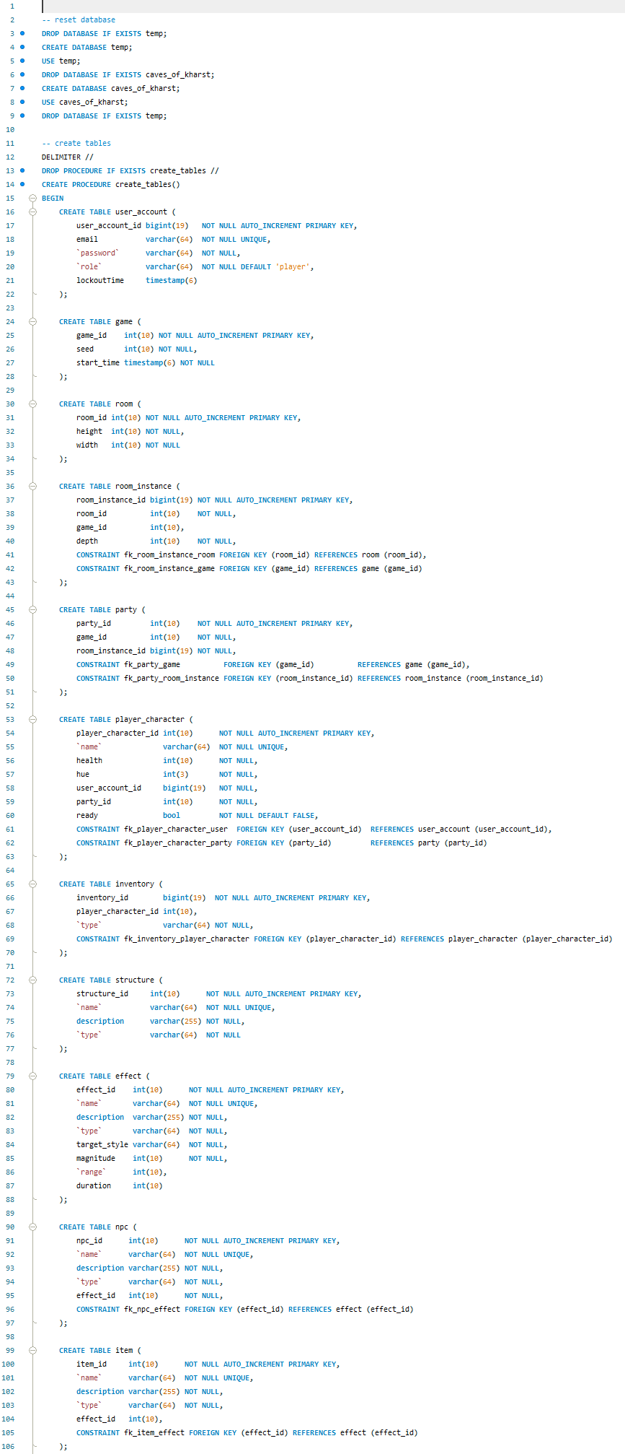
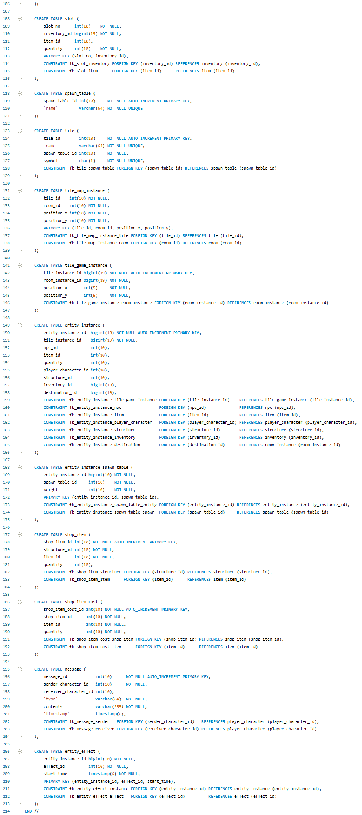
I have created a Preliminary SQL script covering the DDL of the database and allowing its hosting on a MySQL server. Ready for my front-end windows forms application to connect. The script is included in the GitHub repository
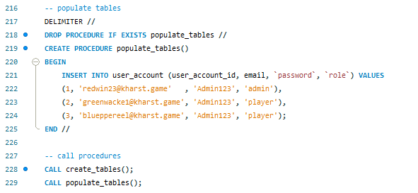

Prototype
I have developed a simple prototype windows forms application. The source code is within the GitHub repository located at:
https://github.com/DylanBroStudent/caves-of-kharst.git
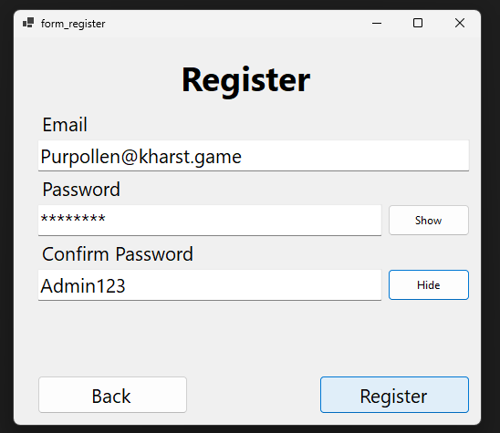
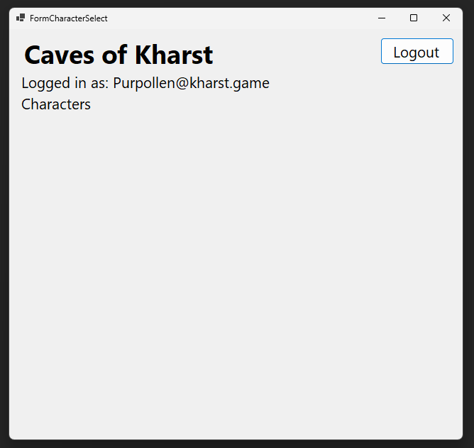
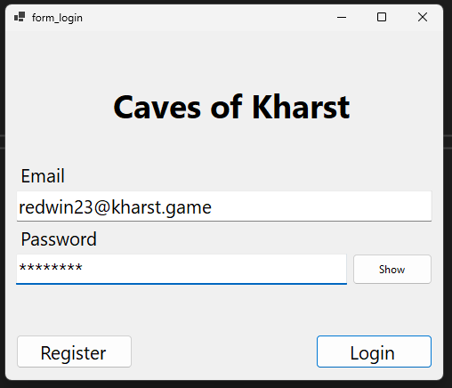
The current prototype supports login and registration. Able to read and write data to the database using a data access object (DAO). As it is a prototype, all data is held in plaintext and must not be used to store any sensitive information. Test accounts are also available from the initial DDL.

